 | Filing Reference : |  | GG/COMS/TS.2/23
 | Document Title : |  | Use-Case Realization Report (Analysis)  View Employee Details
 | Version : |  | 1.0
 | Prepared By : |  | Koh Ming Jin
 | Date Created : |  | Monday, Apr 29th, 2011
Approved By :
 |  | Tran Ba Tien |  | Date
 |  | Project Manager |  | 29th Apr 2011
©2011 [Hoang Kim joint stock Company].
The information contained in this document is the property of [Hoang Kim joint stock Company]. The contents must not be reproduced, wholly or in part, for purposes other than for which it has been supplied, without the prior permission of [Hoang Kim joint stock Company], or, if it has been furnished under contract to another party, as expressly authorised under that contract. [Hoang Kim joint stock Company] shall not be liable for any errors or omissions.

Revision History
Date | Version | Description | Author
29/Apr/11 | 1.0 | Initial Document | Koh Ming Jin

Table of Contents
1. Brief Description 4
2. Flow of Events 4
2.1 Standard Flow 4
2.1.1 Log-In 4
2.1.2 User Functions 4
2.1.3 Log-Out 4
2.2 Exception 5
3. Interaction Diagrams 5
3.1 Collaboration Diagram for View Employee Details 5
4. Participating Objects 5
4.1 View Employee Information Page 5
4.2 Main Page 5
4.3 Main Controller 5
4.4 Employee Controller 5
4.5 Employee 6
5. Class Diagrams 6
5.1 Domain Class Diagram: View Employee 6
6. Derived Requirements 6

Use-Case Realization Report
View Employee Details

Brief Description
This use case enables an operation manager to view an employee details record.

Flow of Events
The standard flow of events for this use case and any exceptions are described in the following subsections. See section 3.1 for an overview of the participating Actors and Domain Objects.

Standard Flow
The flow of events is described as follows:

Log-In
To commence using the system, the Operation Manager is required to log-in successfully as follows:
- Refer to Log In Use Case for details.

User Functions
- The use case starts when Operation Manager selects the View Employee Details option (operation viewEmployeeInfo of MainPage) of the system. This will redirect to the viewEmployeeInformationPage.

- To get the employee list, the following will be performed:
  - Operation viewEmployeeInfo (MainController) will be used to retrieve all the employee details by calling theoperation retrieveEmployeeInfo of object Employee Controller.
  - Employee Controller will call the operation getEmployeeDetails of Employee object
  - Operation returnEmployeeInfo (EmployeeController) will return the list of employees to viewEmployeeInformationPage (i.e. operation show)
- The View Employee Information Page, which includes all the employee details, is displayed.

- The Operation Manager can click on the employee’s ID (operation viewAParticularEmployeeInfo) to view more details about the selected employee.

- To get the selected employee details, the following will be performed:
  - View Employee Information Page will call the operation returnSelectedEmployeeInfo of EmployeeController
  - EmployeeController will retrieve the selected Employee object (i.e. operation: getAnEmployeeDetails)
  - EmployeeController will return the information using the operation returnSelectedEmployeeInfo

- The selected employee details will be shown in the View Employee Information Page

Log-Out
- The Operation Manager will terminate use of COMS (ie: log-out) by pressing a button with the caption “Log Out”.
- Refer to the Log Out Use Case for details.

Exception
- If the system is not able to retrieve the employee information, an error will be displayed. This will instruct the actor to contact the administrator.

Interaction Diagrams

Collaboration Diagram for View Employee Details

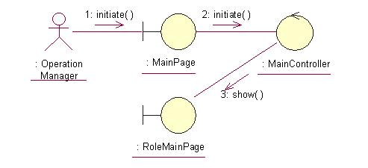
The above collaboration diagram shows the process flow after the actor has login.

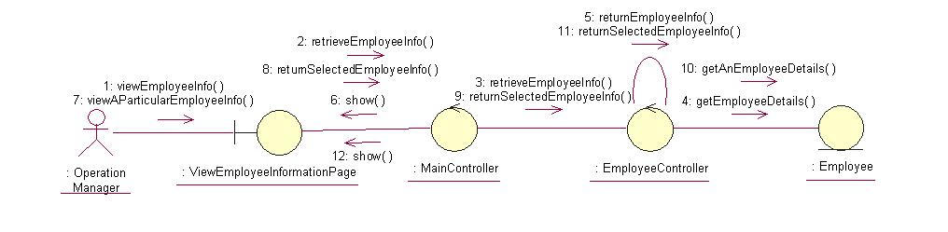
The above collaboration diagram shows the main process flow of this use case.

Participating Objects

View Employee Information Page
This object renders the contents to allow authorized actors to view the employee information. The Director, Department Manager and Operation Manager actors use this object.

Main Page
This object renders the contents (based on the user role) after the actor has login. The Director, Department Manager and Operation Manager actors use this object.

Main Controller
This object acts as the middleman between Main Page and the Employee Controller. It will translate interactions with the view into actions to be performed by the Employee Controller.

Employee Controller
This object acts as the middleman between “View Employee” Page and the Employee object. It will translate interactions with the view into actions to be performed by the Employee object.

Employee
This object stores the details concerning the employee of the COMS.

Class Diagrams

Domain Class Diagram: View Employee

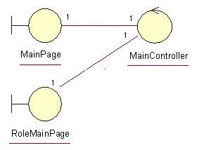

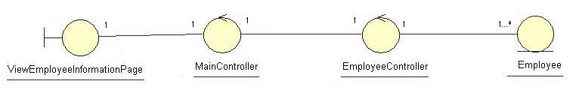

Derived Requirements
The Operation Manager PC keyboard and mouse will be used to retrieve employee details (if any) and view all the system responses.

